
Installation Manual

1. Double-click the appropriate WampServer installation
for Windows (32-bit or 64-bit)

2. Click the ‘Run’ button

3. Click the ‘Next’ button

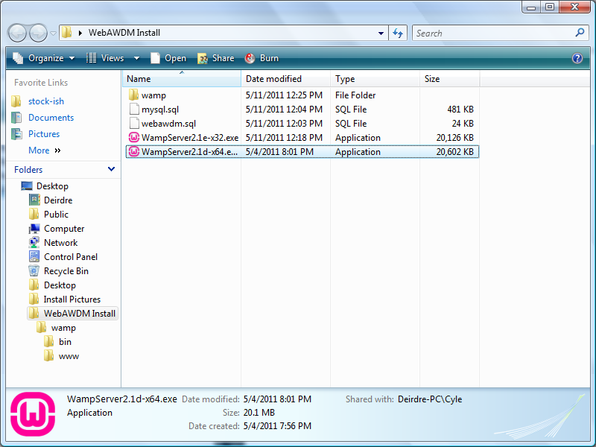

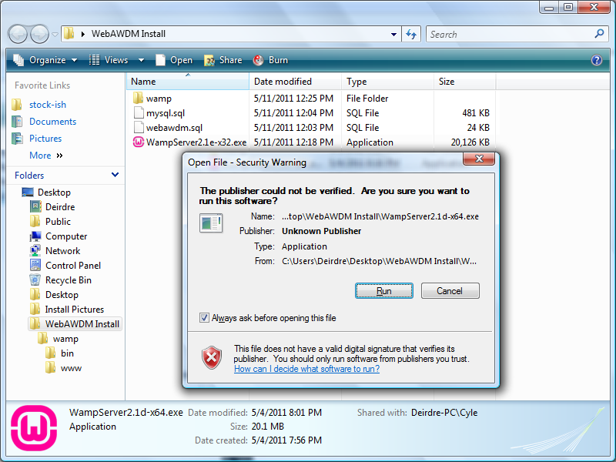

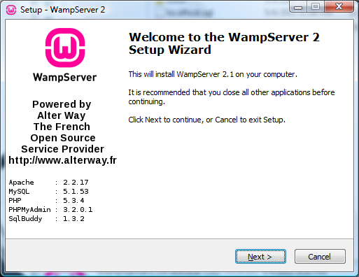

4. Select ‘I accept the agreement’, click the ‘Next’ button

5. Install to C:\wamp, click the ‘Next’ button

6. Check ‘Create a Desktop icon’, click the ‘Next’ button

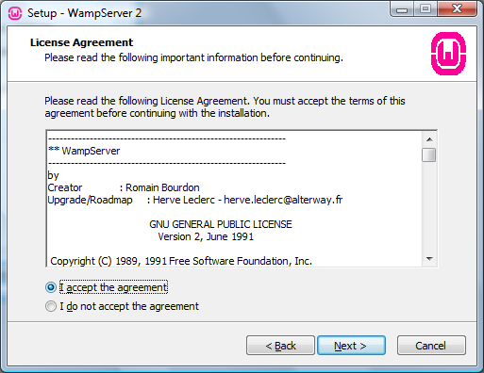

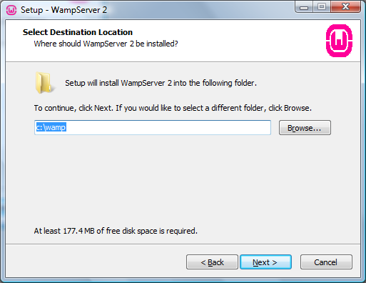

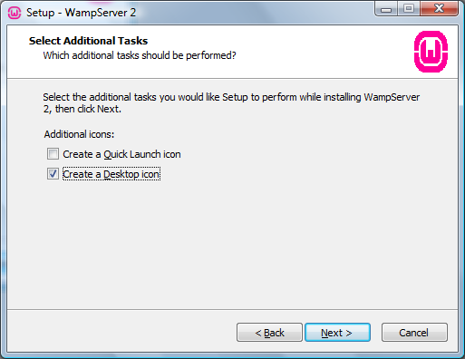

7. Click the ‘Install’ button

8. (Installation Screen)

9. Navigate to the directory:
C:\Program Files\Mozilla Firefox, select firefox.exe

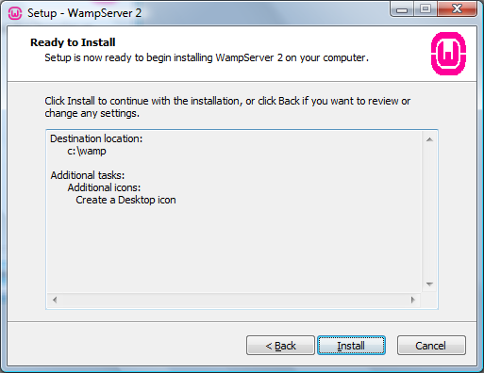

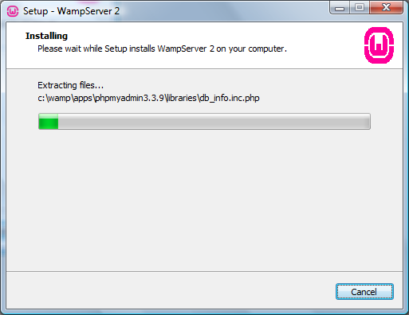

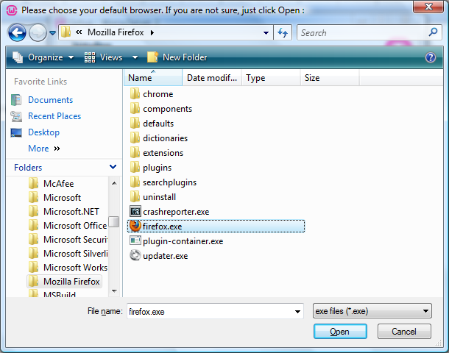

10. Click the ‘Unblock’ button

11. Fill in SMTP: smtp.gmail.com
Email: WebAWDM@gmail.com

12. Uncheck ‘Launch WampServer 2 now',
click the ‘Finish’ button

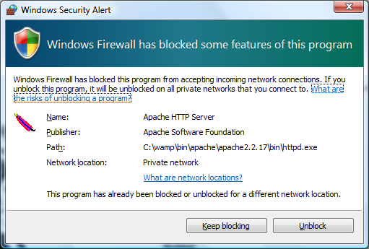

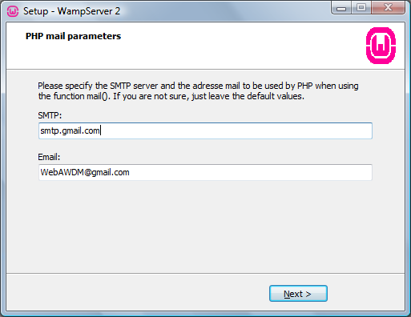

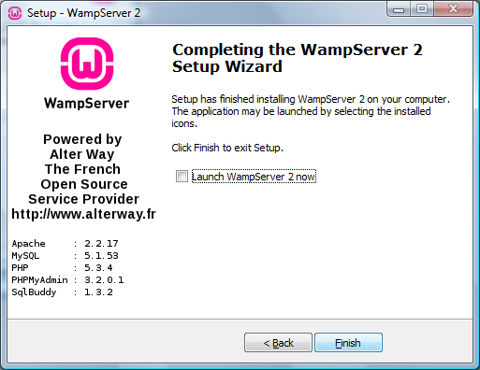

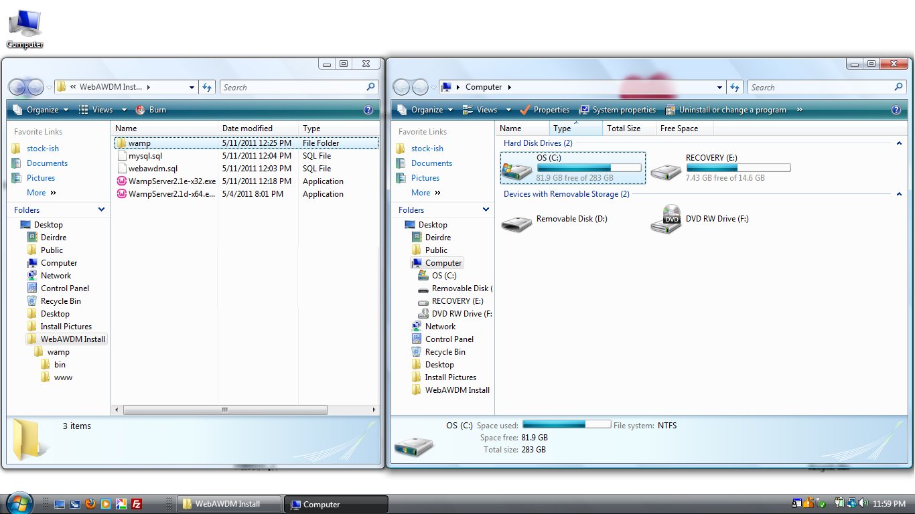
13. Double-click ‘My Computer’,
-click the (C:) Drive icon

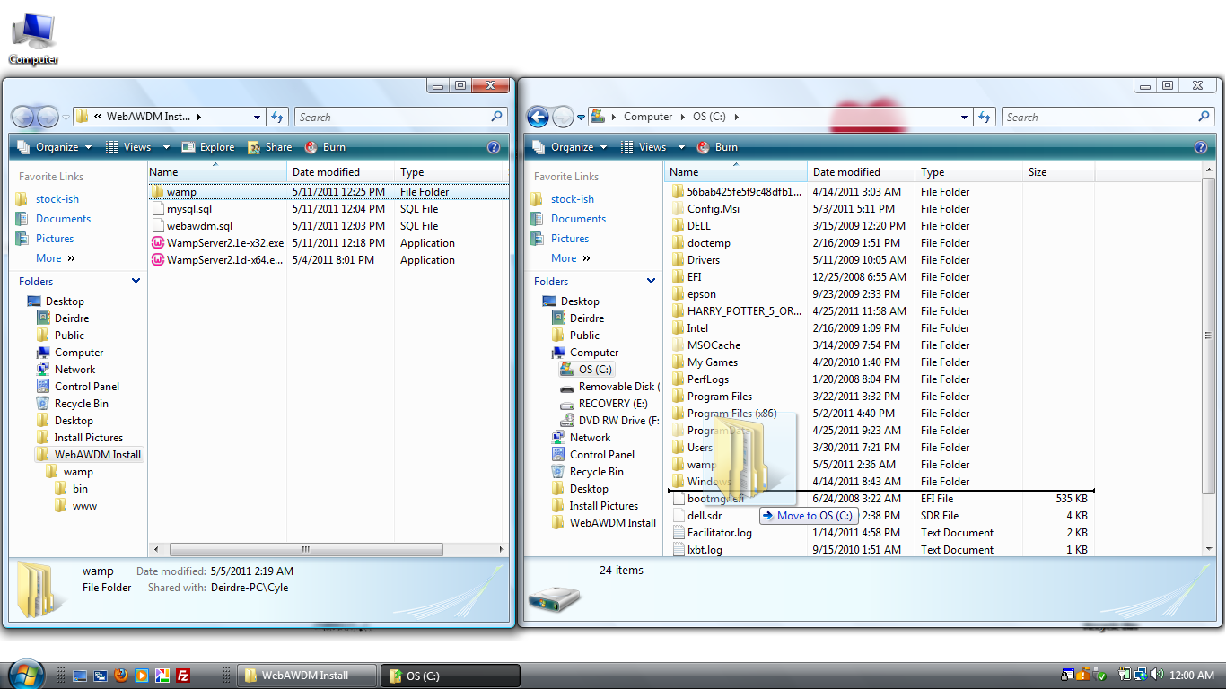

14. Drag the ‘wamp’ folder to the
(C:) Drive

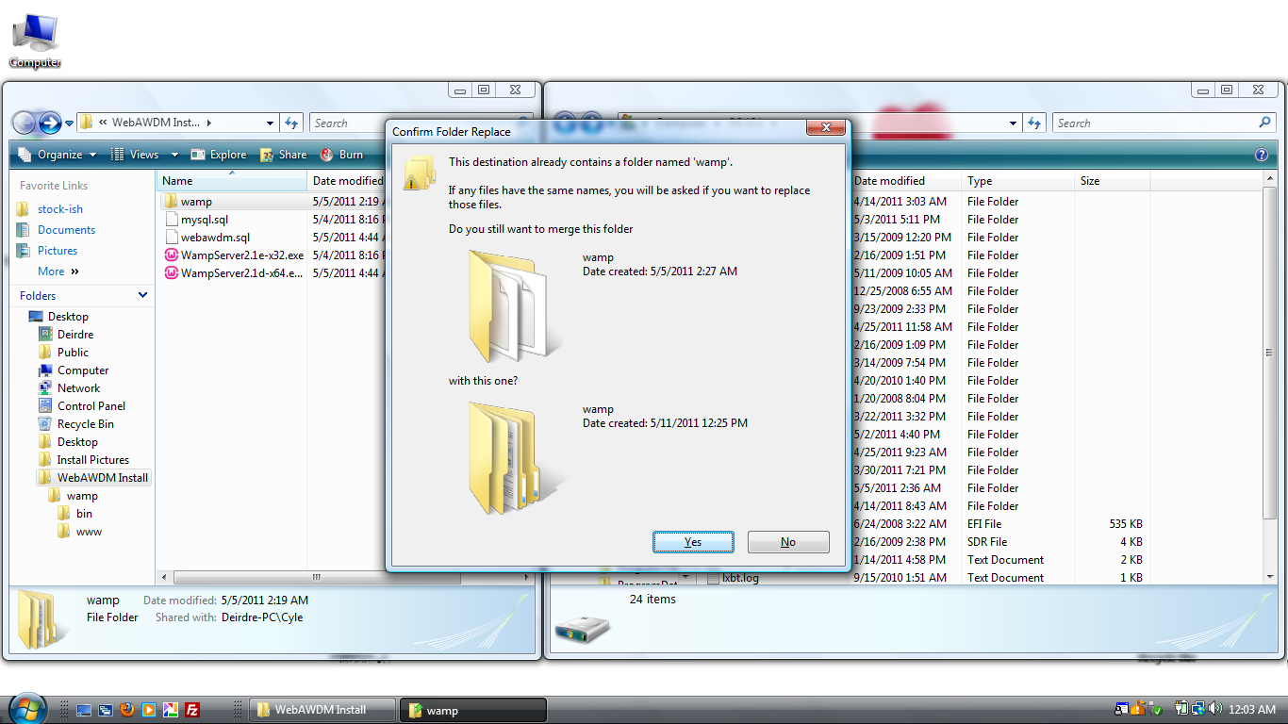

15. Click the ‘Yes’ Button

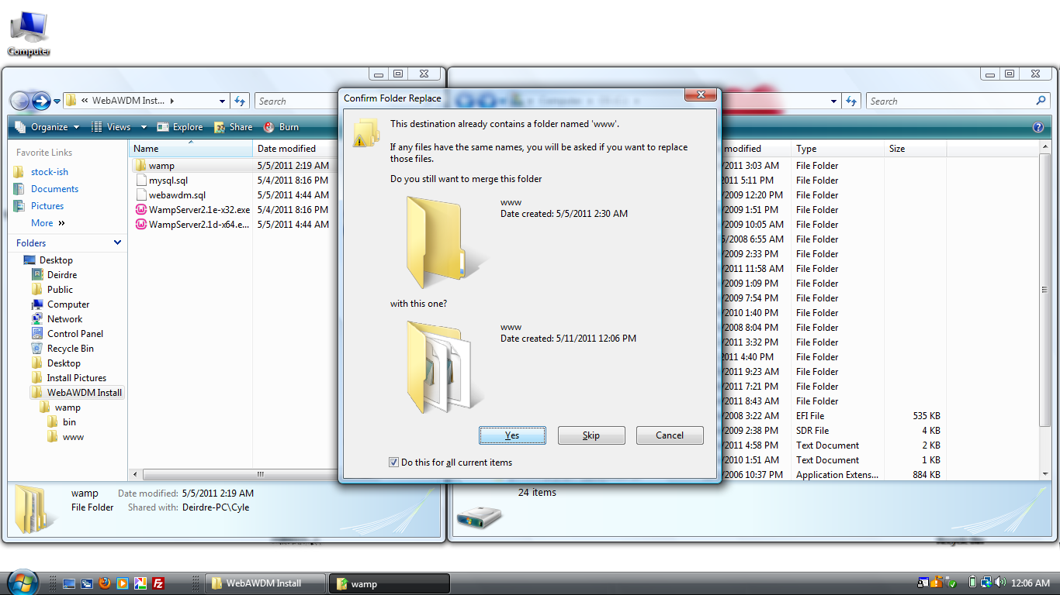

16. Check ‘Do this for all current items’,
click the ‘Yes’ button

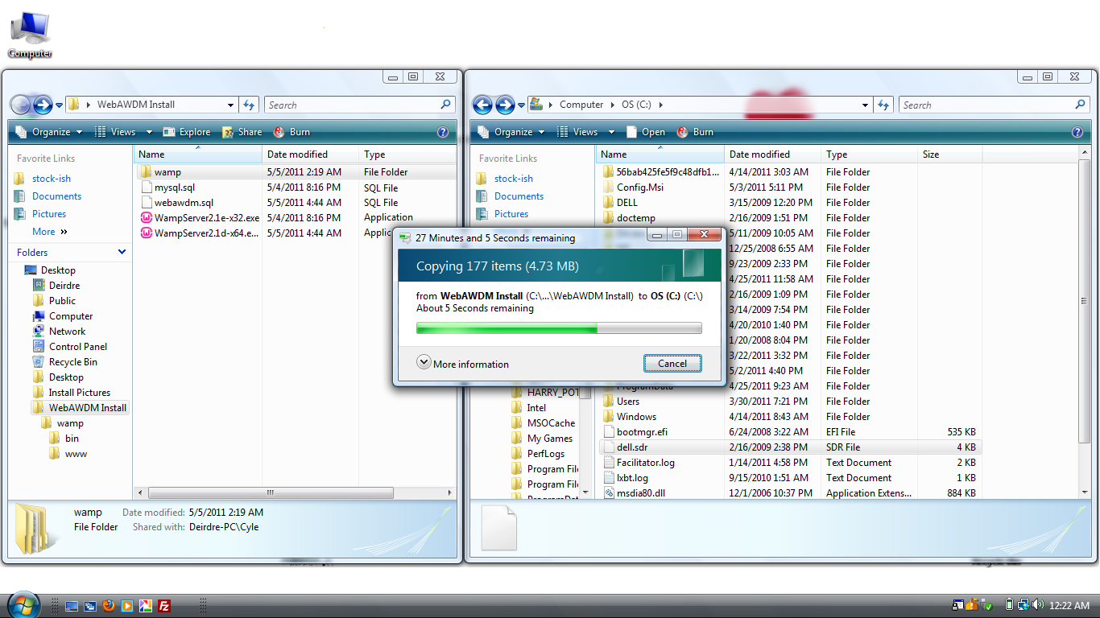

17. (File Transfer)

18. Double-click the ‘WampServer’ icon to start WampServer Manager
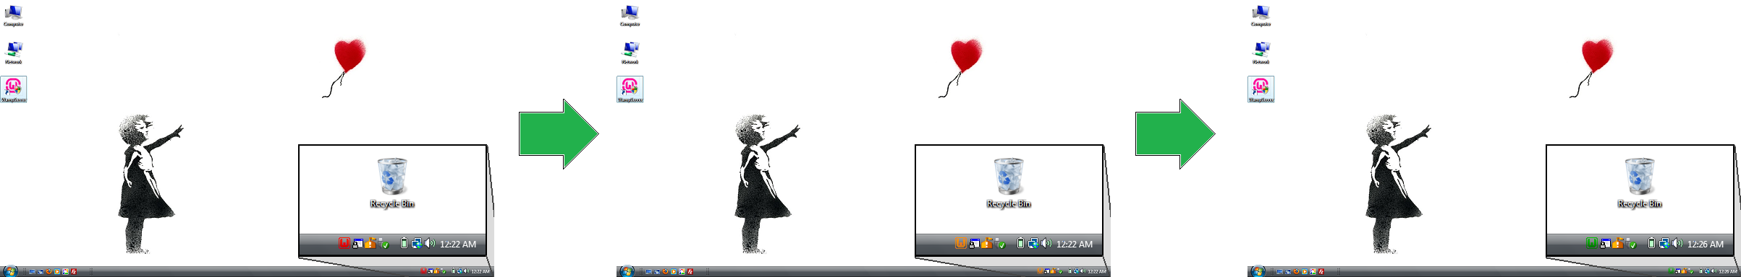

The icon in the taskbar (bottom left corner) will go from red (initialize), orange (startup), then finally green (ready)

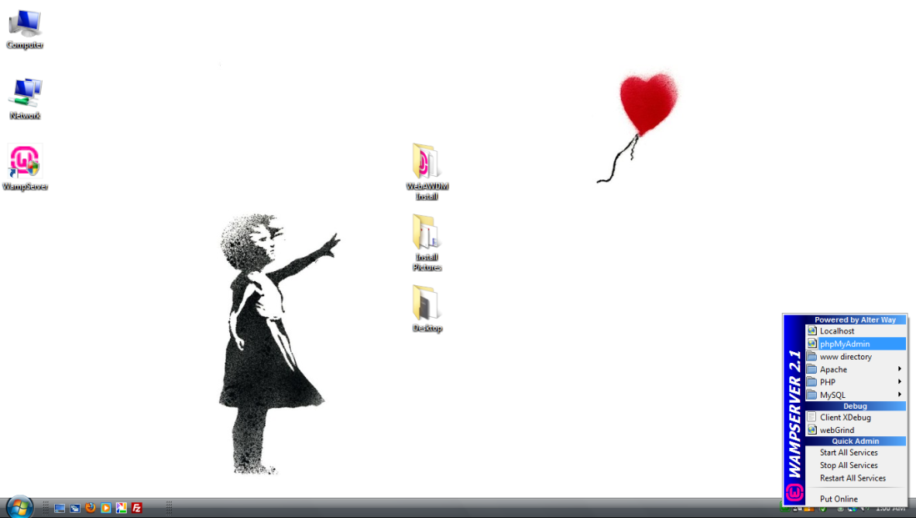

19. Left-click the WampServer icon
(bottom left corner) and
click the ‘phpMyAdmin’ option

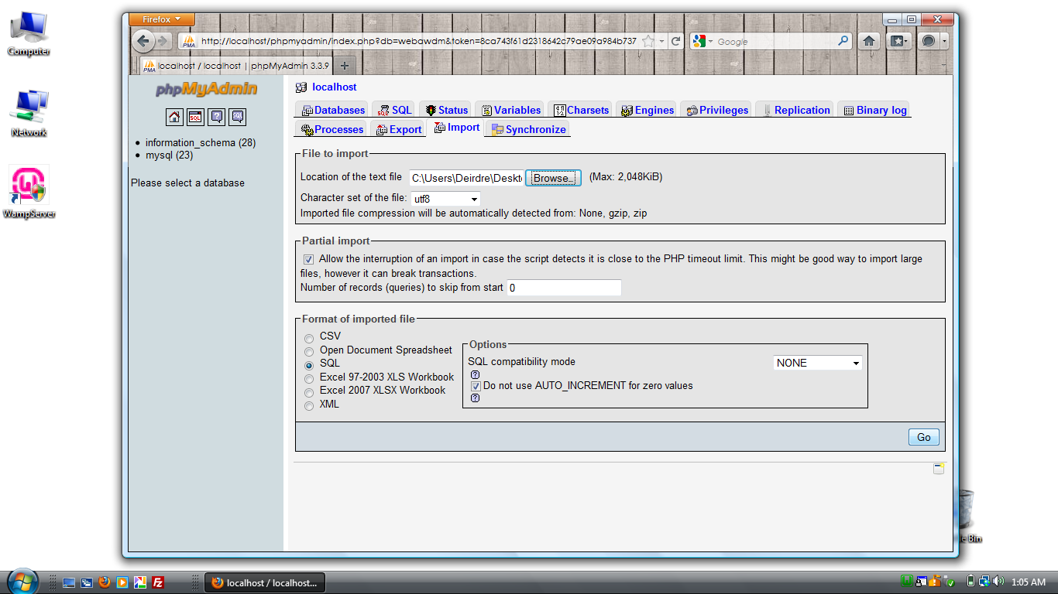
20. Left-click on the ‘Import’ tab,
click the ‘Browse’ button

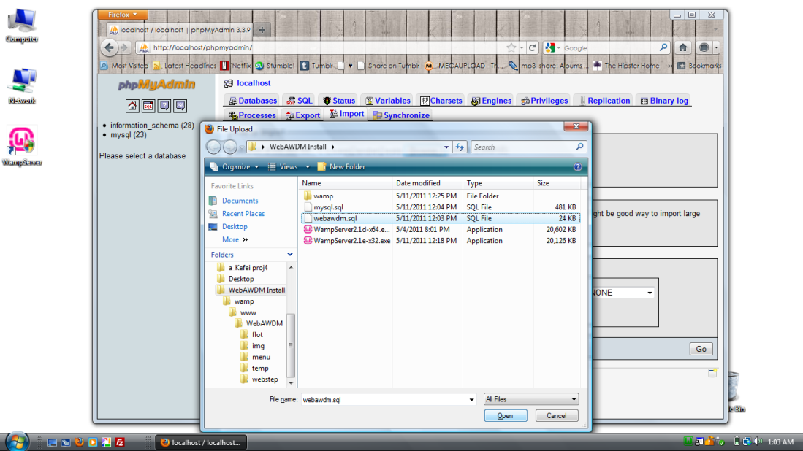
21. Select ‘webawdm.sql’ file,
click the ‘Open’ button,
then click the ‘Go’ button

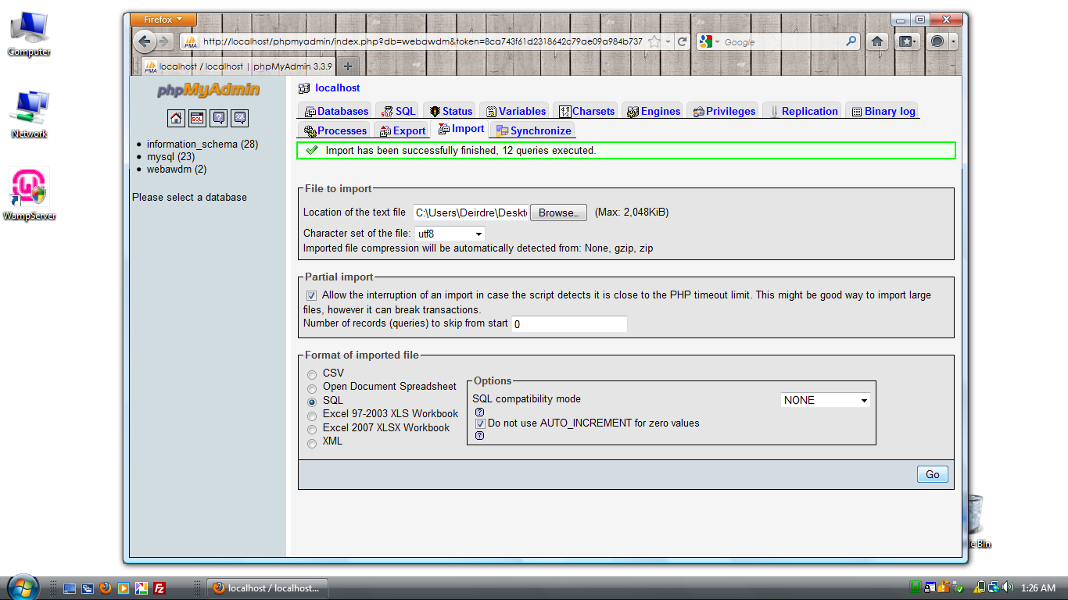
22. Click the ‘Browse’ button

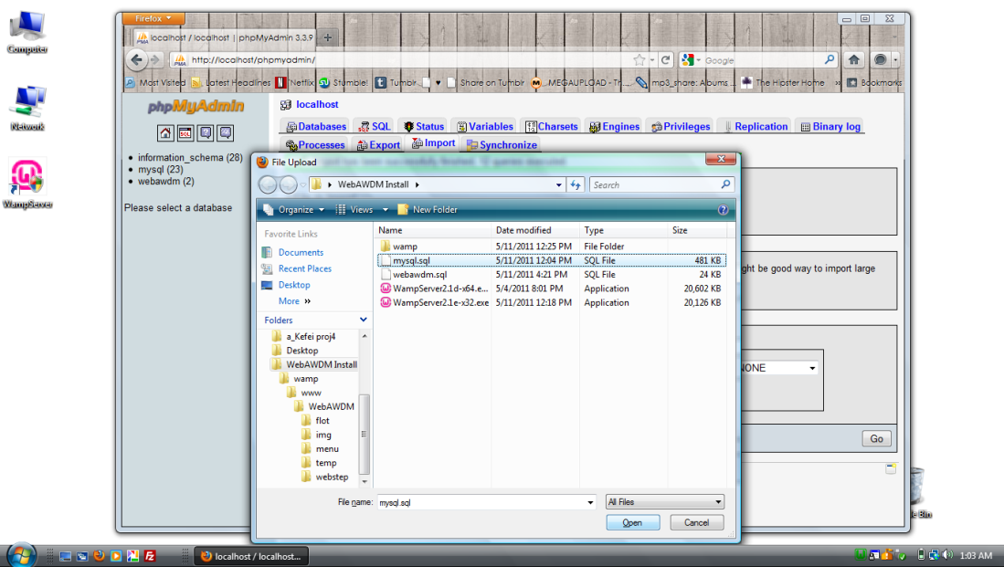
23. Select ‘mysql.sql’ file,
click the ‘Open’ button,
then click the ‘Go’ button

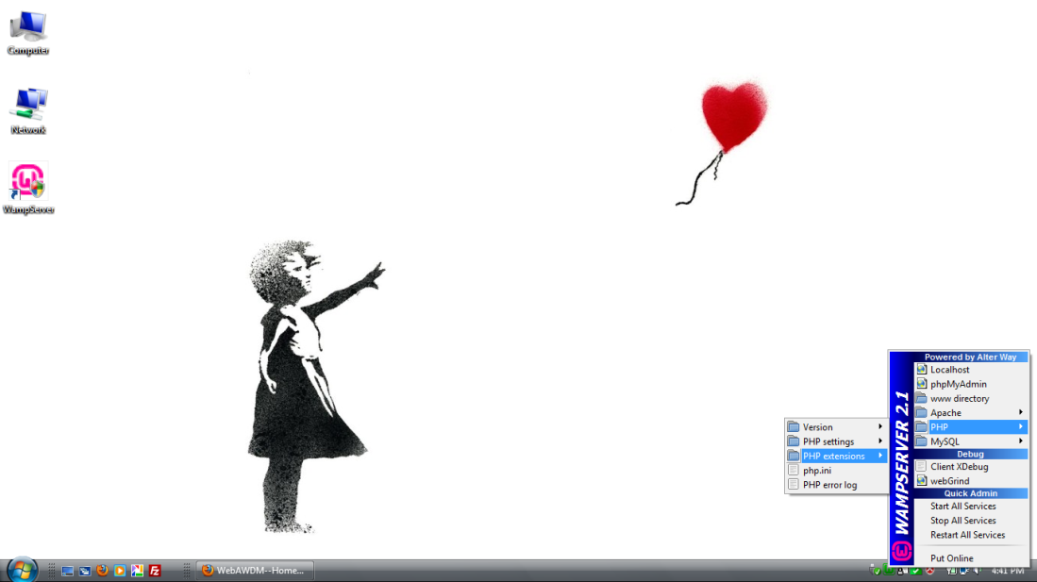
24. Close Mozilla Firefox,
left-click the WampServer icon
(bottom left corner) and
click the ‘PHP extensions’ option

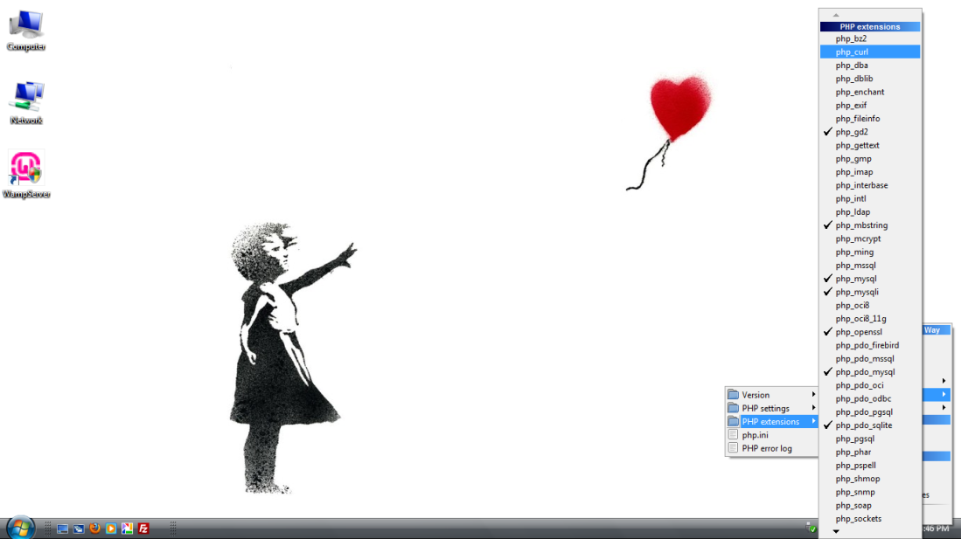
25. Click the ‘php_curl’ option

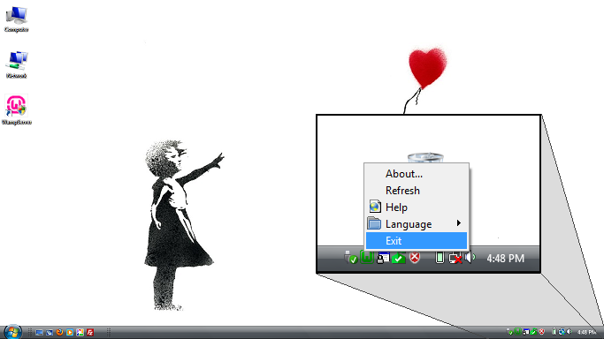

26. Right-click the WampServer icon
(bottom left corner) and
click on the ‘Exit’ option, then
double-click the ‘WampServer’ icon
to restart WampServer Manager

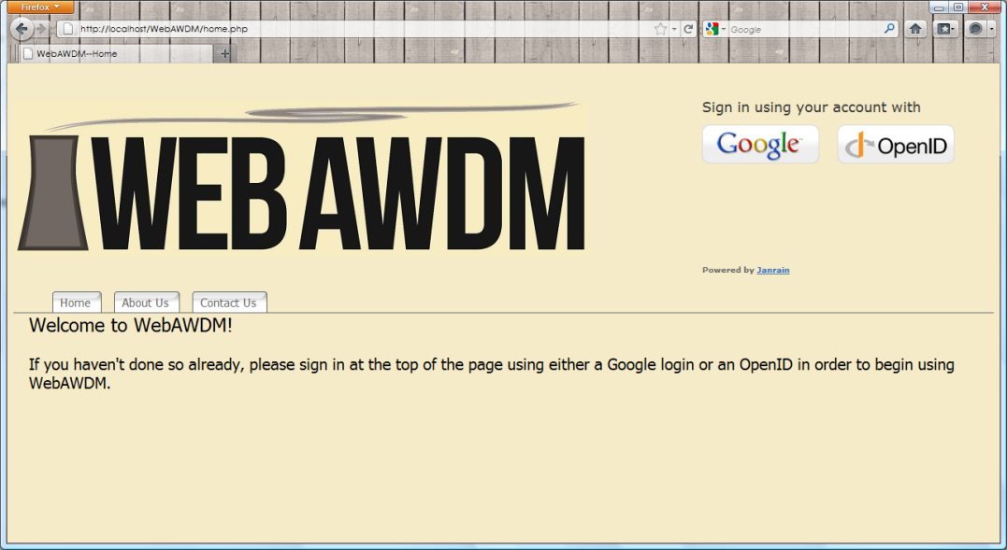

27. Reopen ‘Mozilla Firefox’,
enter the Address:
http://localhost/WebAWDM/home.php
and begin WebAWDM.

